ZOMATO BANGALORE RESTARUANT ANALYSIS
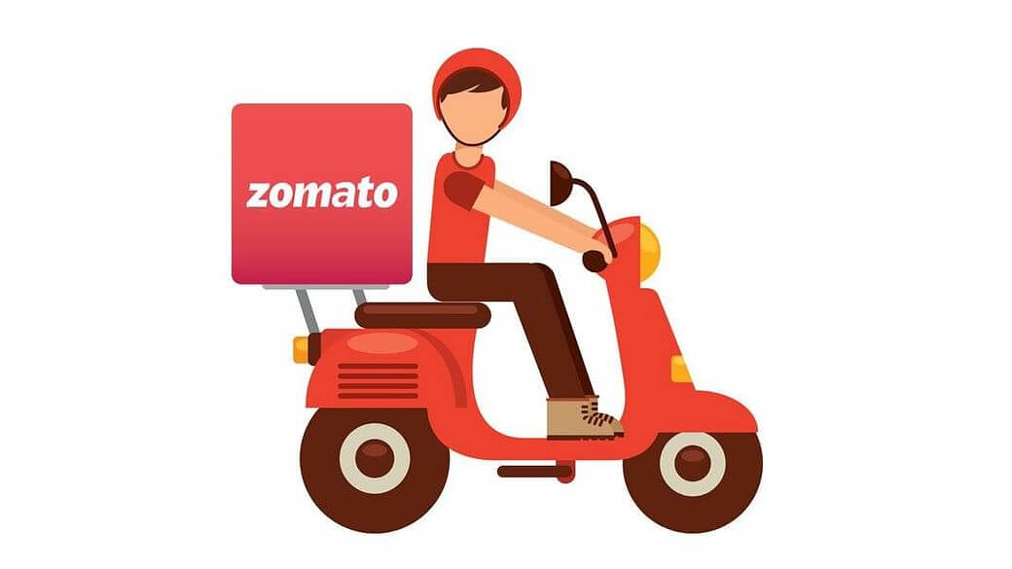

ABOUT ZOMATO
Bangalore is a city with a large number of restaurants and a rich food culture. People in Bangalore prefer different types of cuisines, price ranges, and dining options. Zomato is a popular food app that provides information about restaurants such as location, ratings, cost, and services.
The Zomato Bangalore restaurant analysis helps to understand customer preferences and restaurant trends in the city. By analysing this data, we can identify popular areas, common cuisines, price patterns, and factors that affect restaurant ratings. This analysis is useful for restaurant owners, customers, and businesses to make better decisions.
This analysis aims to explore the Bangalore restaurant landscape using Zomato data to uncover meaningful insights that can support decision-making for restaurant owners, food entrepreneurs, marketers, and customers. The study focuses on understanding customer behaviour, competitive trends, and key attributes that contribute to a restaurant’s success in Bangalore’s highly competitive food industry.

PROBLEM STATEMENT

- Bangalore has a large and competitive restaurant market.
- Customers have diverse preferences in terms of cuisine, price, and location.
- Restaurant owners find it difficult to understand customer behaviour and preferences.
- Ratings and reviews vary across restaurants, and the reasons are not always clear.
- Factors such as cost, cuisine type, online ordering, and table booking impact restaurant performance.
- There is a need to analyse Zomato Bangalore data to identify trends and patterns.
- The analysis helps in understanding popular locations, preferred cuisines, and pricing strategies.
- Insights from the analysis can support better decision-making for restaurant owners and customers.


DATASET DESCRIPTION

The dataset contains information about restaurants listed on Zomato Bangalore including:
- Restaurant name
- Location
- Online order availability
- Table booking availability
- Ratings and votes
- Cost for two people
- Restaurant type and cuisines
- Delivery or dine-out ca


1.ANALYSING BASIC METRICS
Basic metrics are numerical measures used to summarize, understand, and analyse data.
Import libraries:
Open Jupiter Notebook
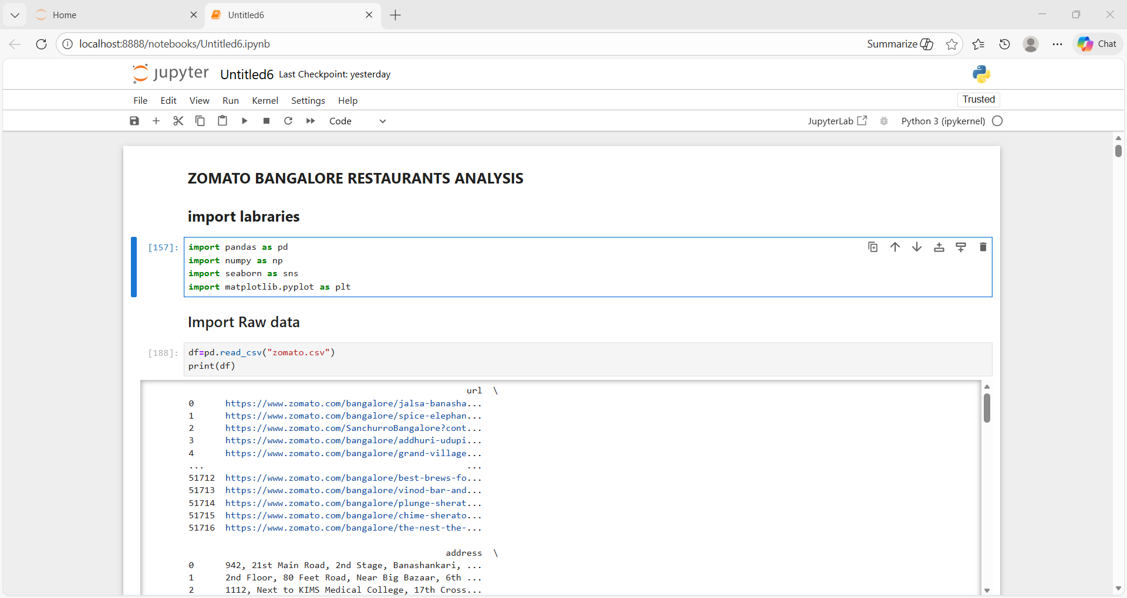
Import raw data:
- Open Jupiter Notebook
- On the home page, click Upload (top-right)
- Select your .csv file
- Click Upload again (next to the file name)
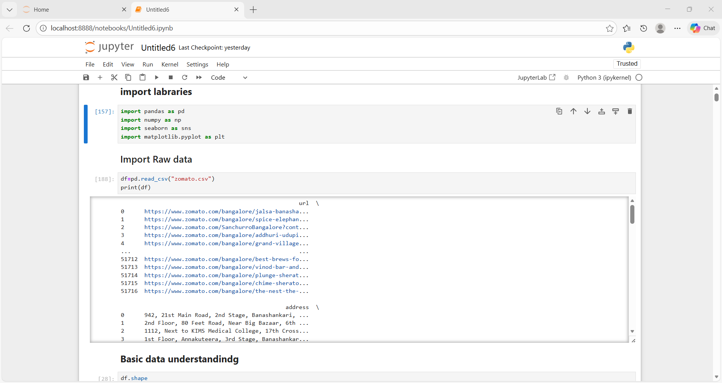
Shape of Dataset
Shows total number of rows (restaurants) and columns (features)
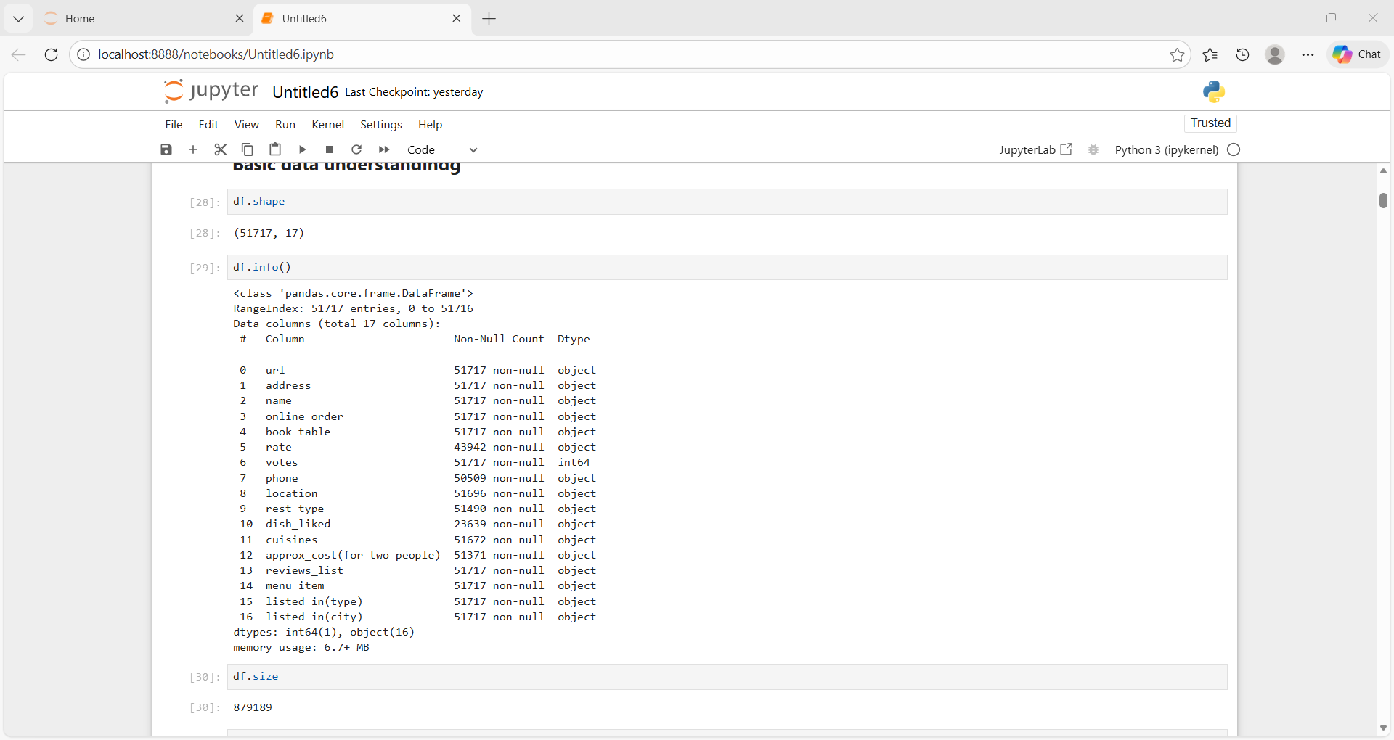
Size of Dataset
Total number of data values (rows × columns)

Info of dataset
To display a summary of a DataFrame, including its structure and data types.


Head of Dataset
Displays first 5 records to understand data structure
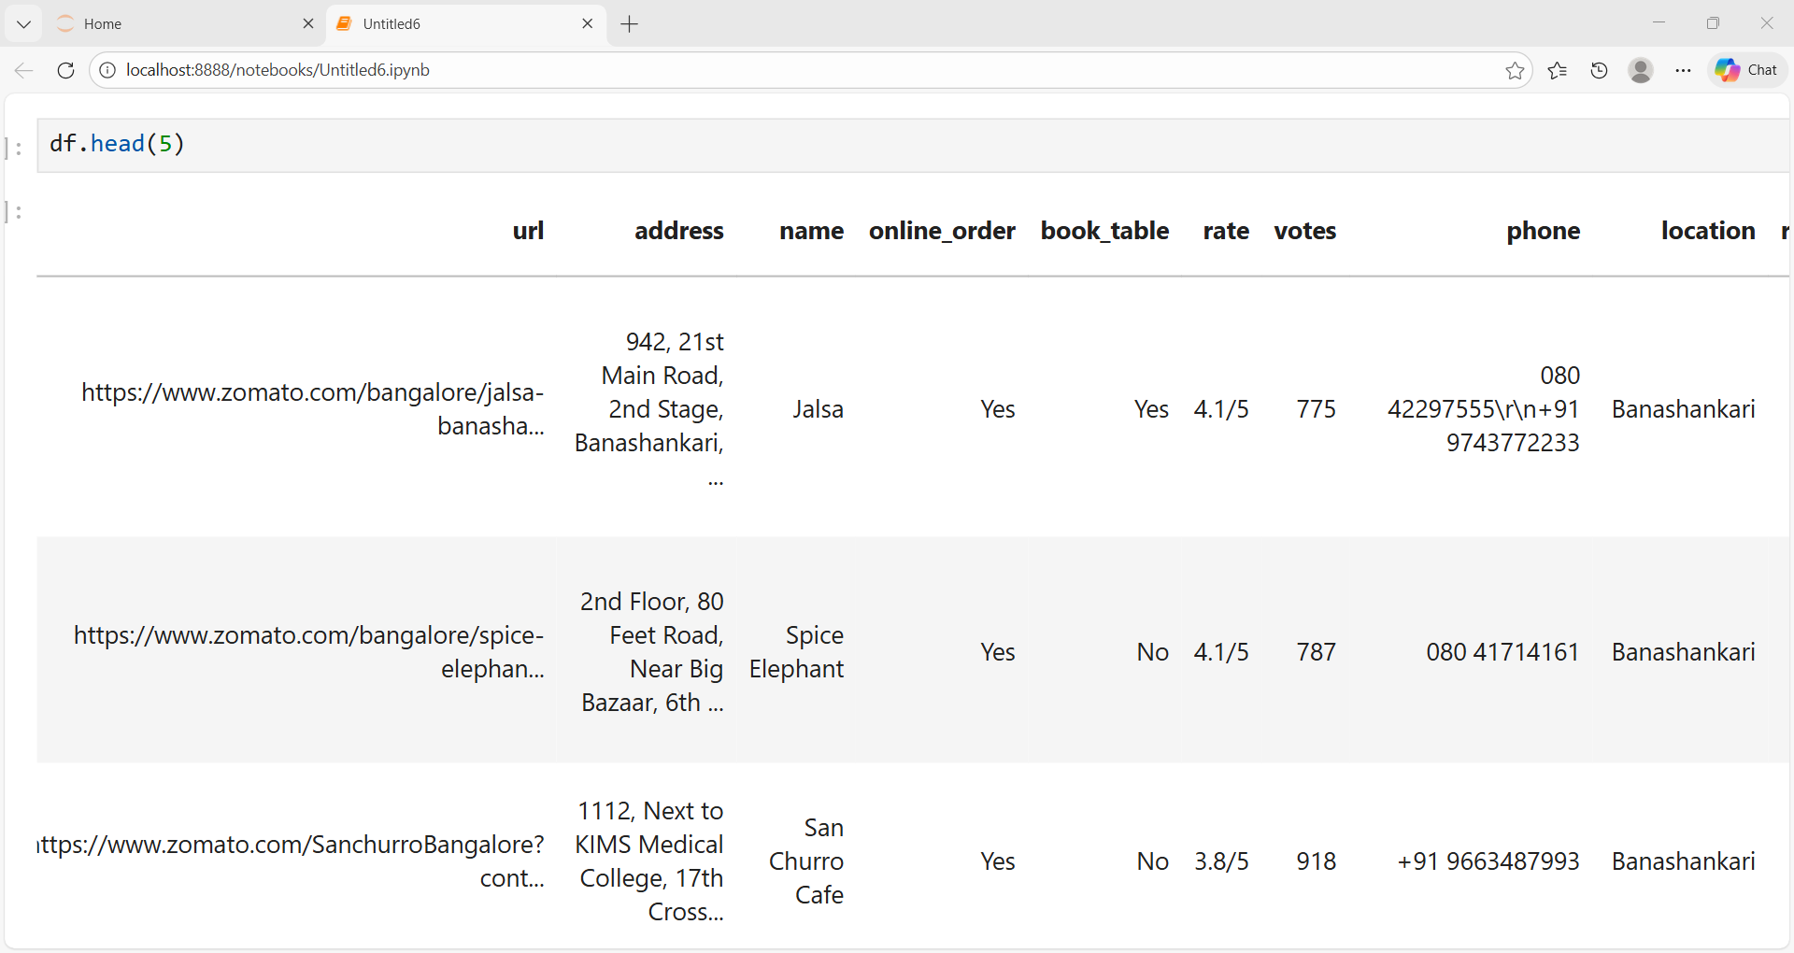
Tail of Dataset
Displays last 5 records to check data consistency
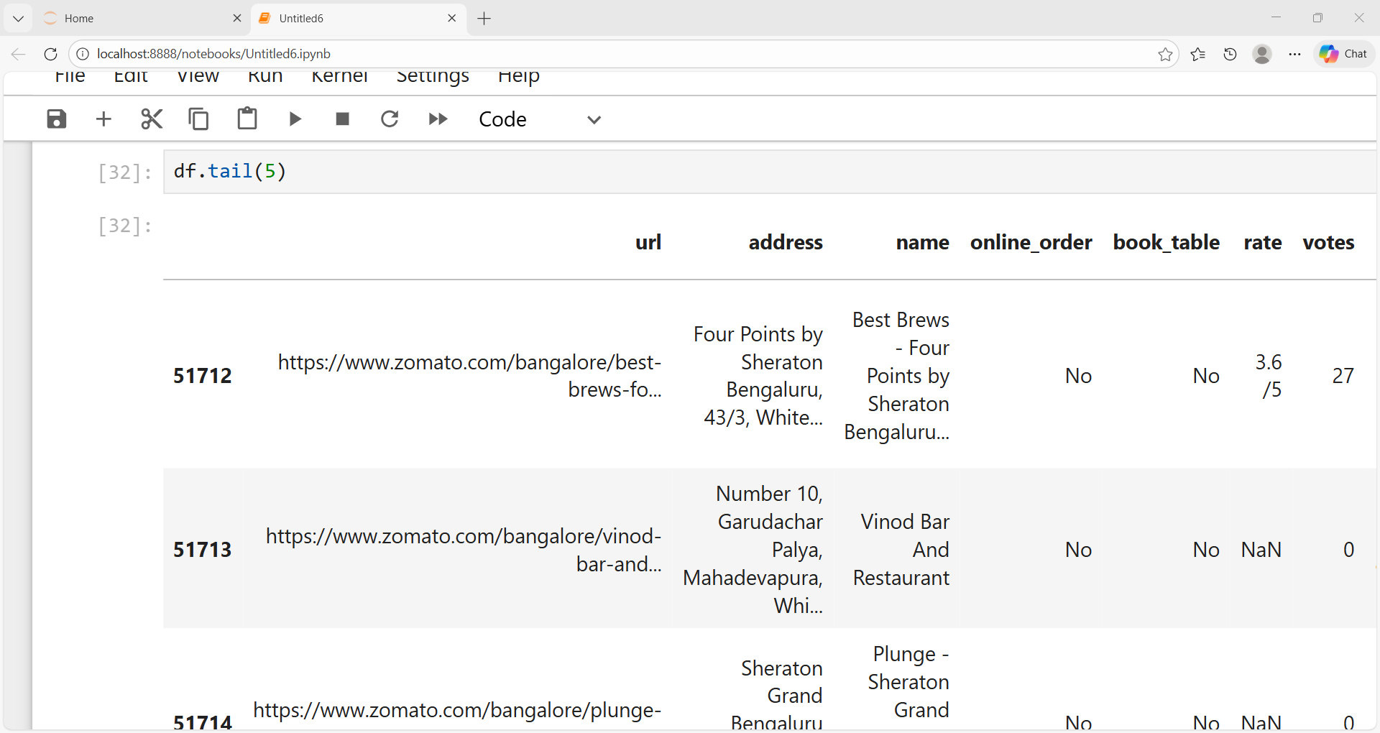
Column Names
List of all features present in the dataset
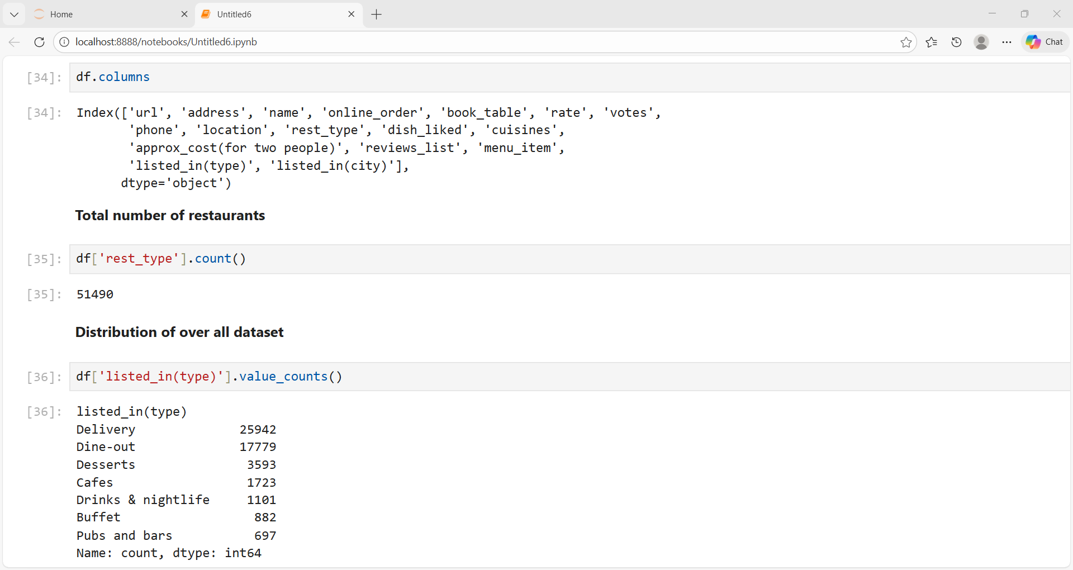

Total number of restaurants
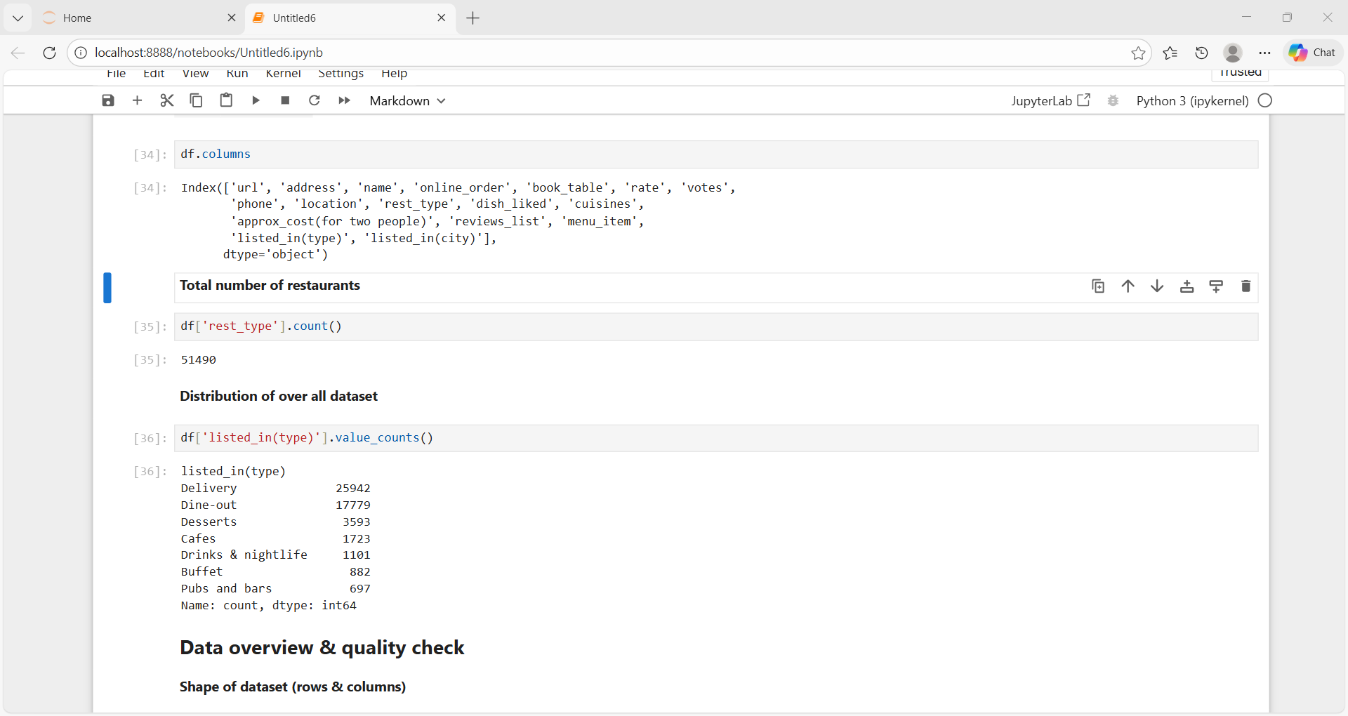
Distribution of over all dataset
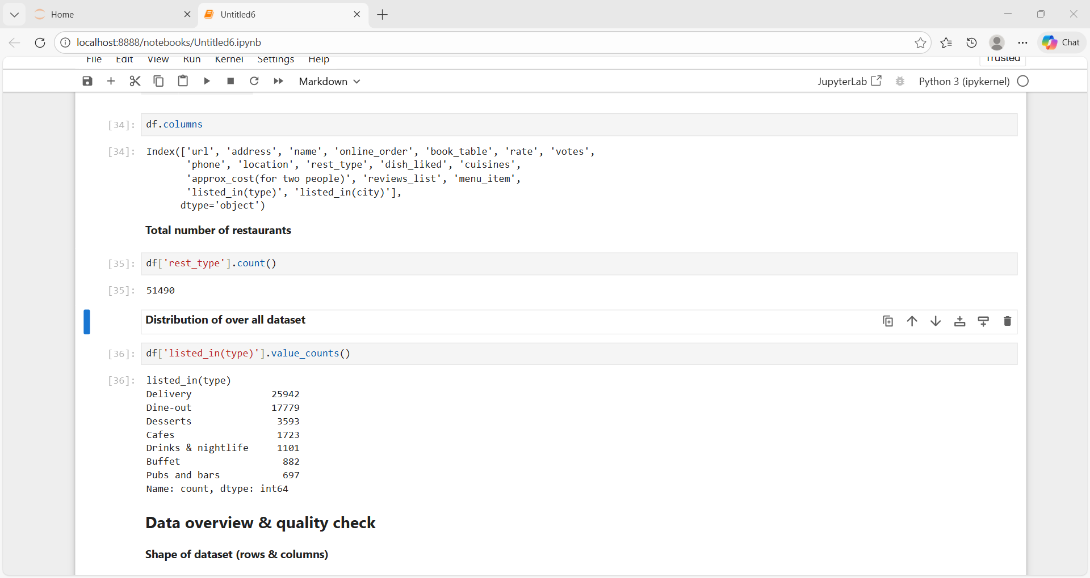
2.Data overview & quality check
Data Types
Identifies numeric and categorical columns
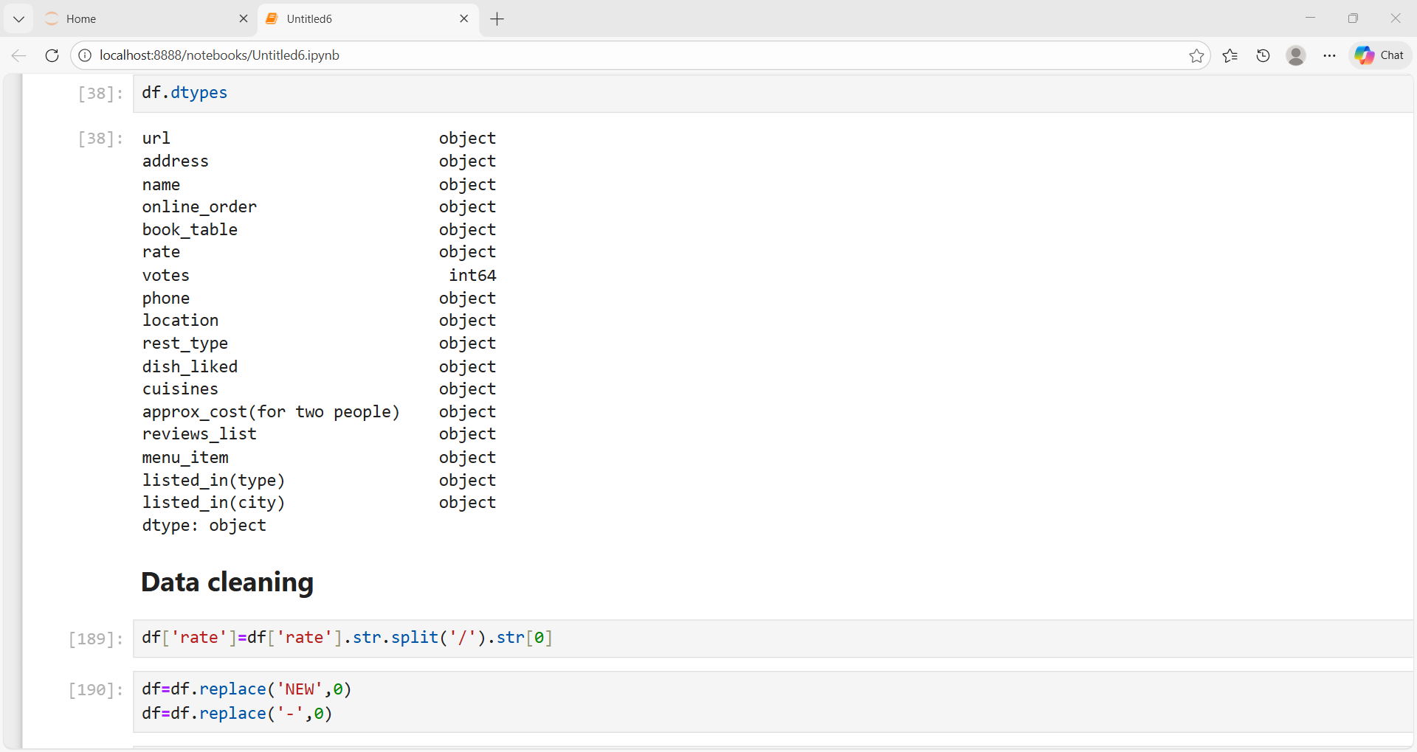
Conversion of categorial columns to category
Categorical data conversion is the process of transforming text or label-based data into numerical form so that it can be used for analysis

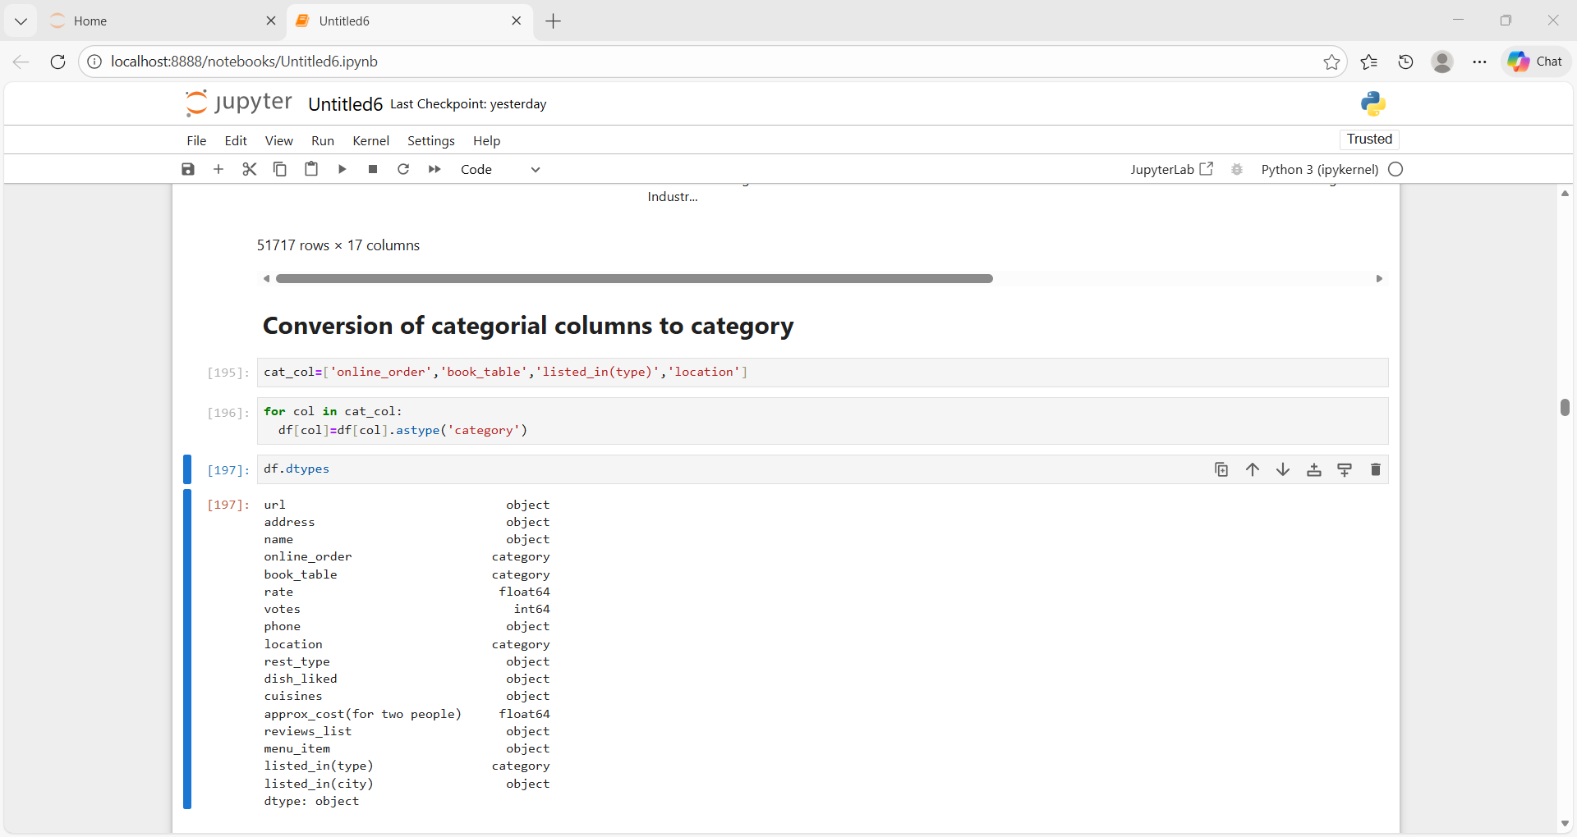
missing value detection
Missing values detection is the process of identifying empty, null, or undefined values in a dataset before handling or replacing them.
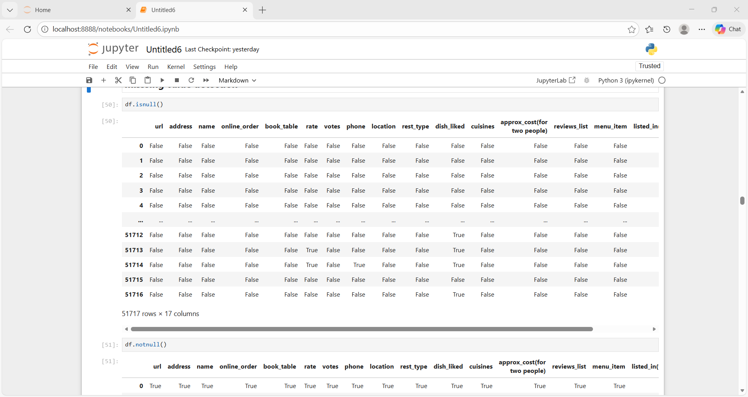
Fill NA
Used to replace missing values (Nan, None) In a dataset
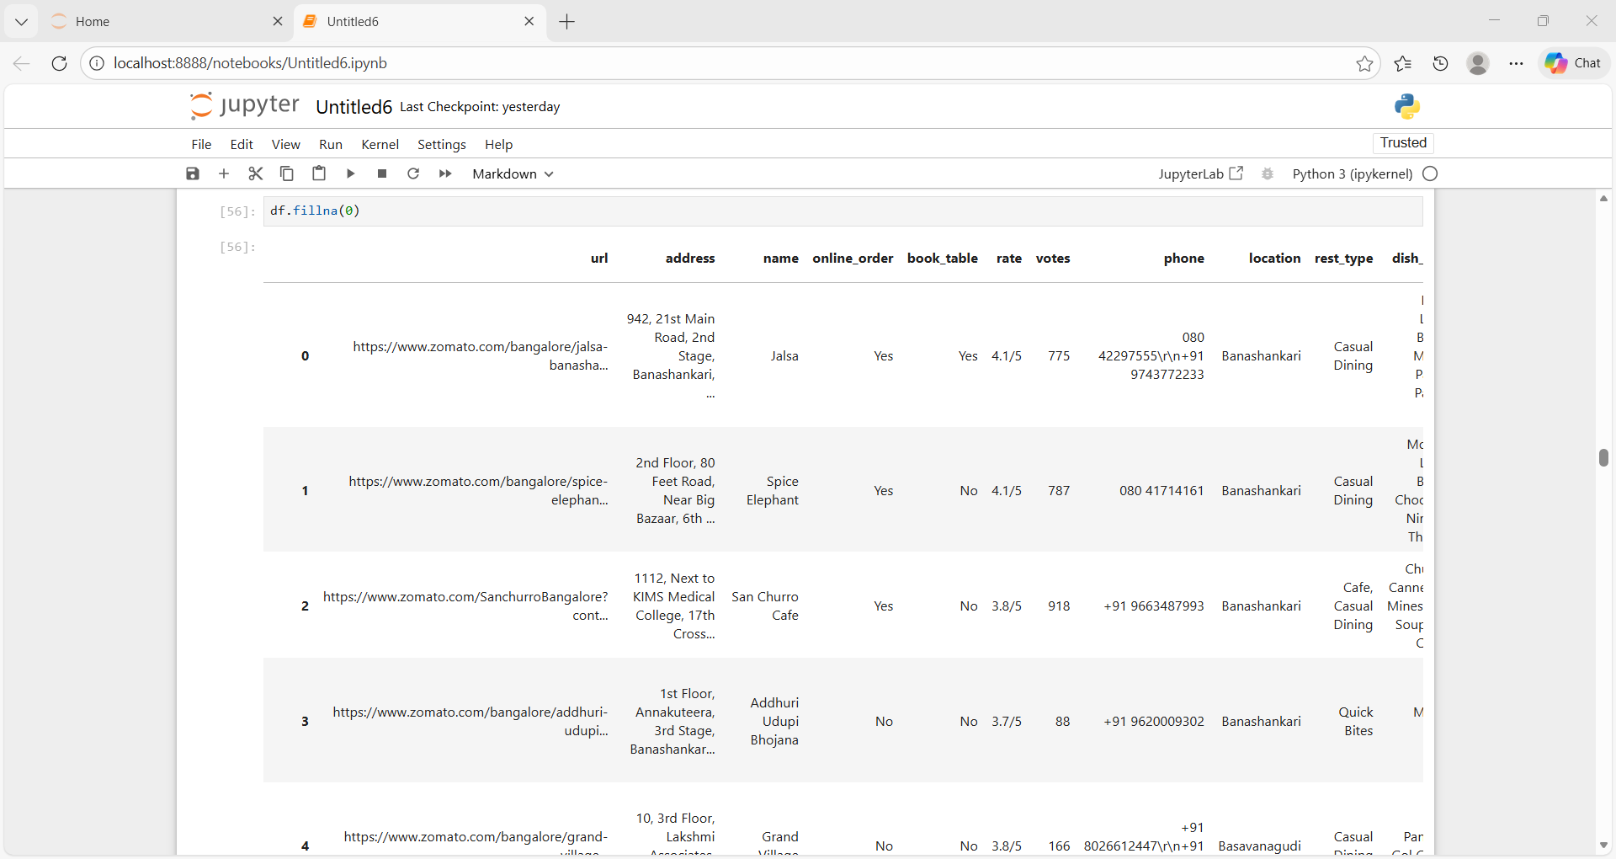
Drop rows
Removing entire records (rows) that contain one or more Nan / null values from the dataset.
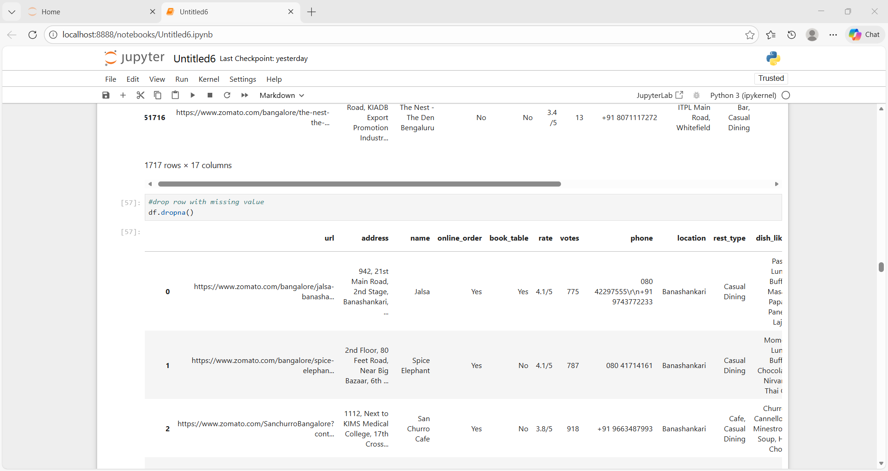
Drop columns
Removing entire records (columns) that contain one or more Nan / null values from the dataset.
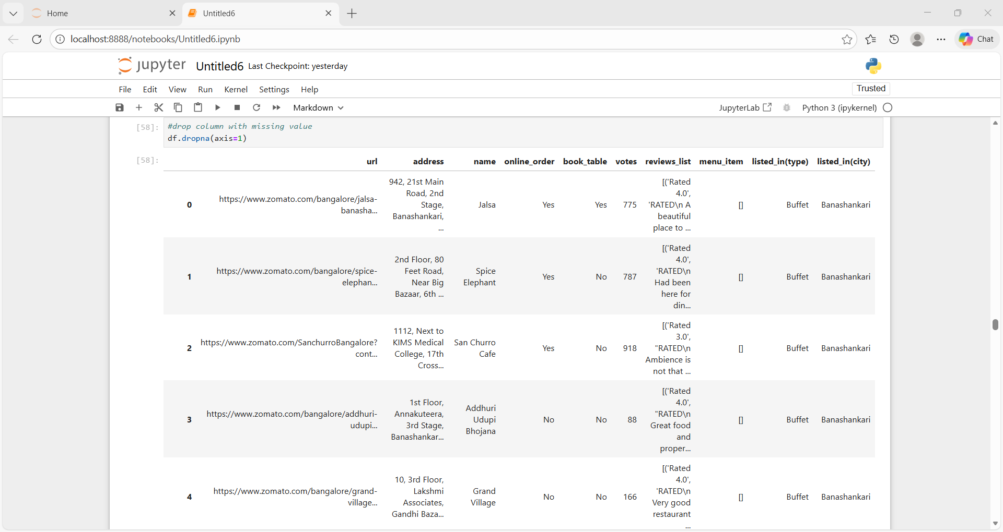
Describe
Summary statistics like count, mean, min, max for numerical columns
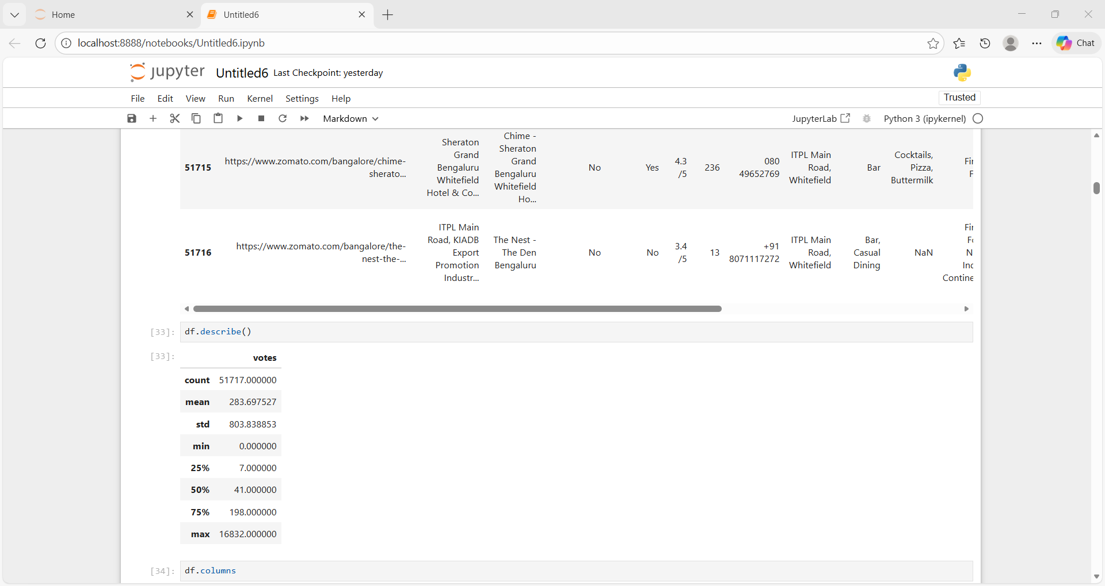
Non-graphical analysis
Value counts: Value counts refer to the number of times each unique value appears in a dataset or in a specific variable/column.
Online ordering:
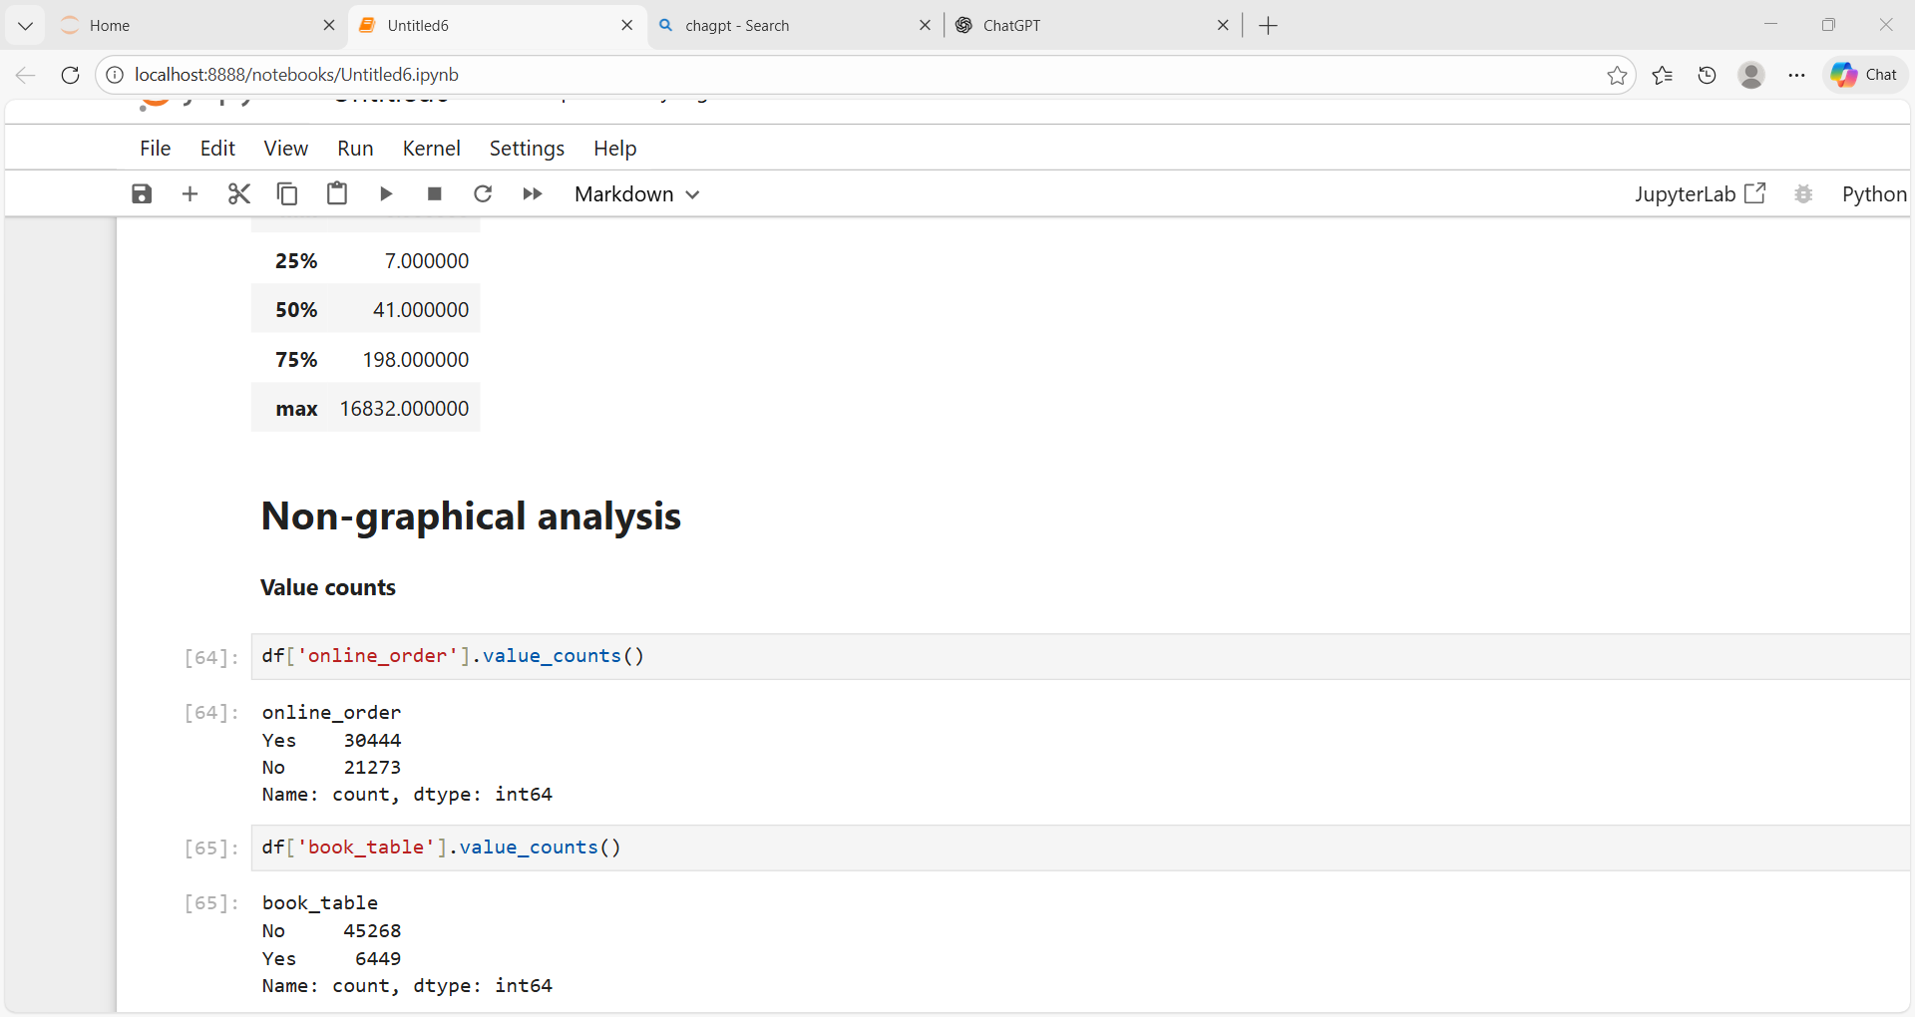
Table booking:

Restaurant types
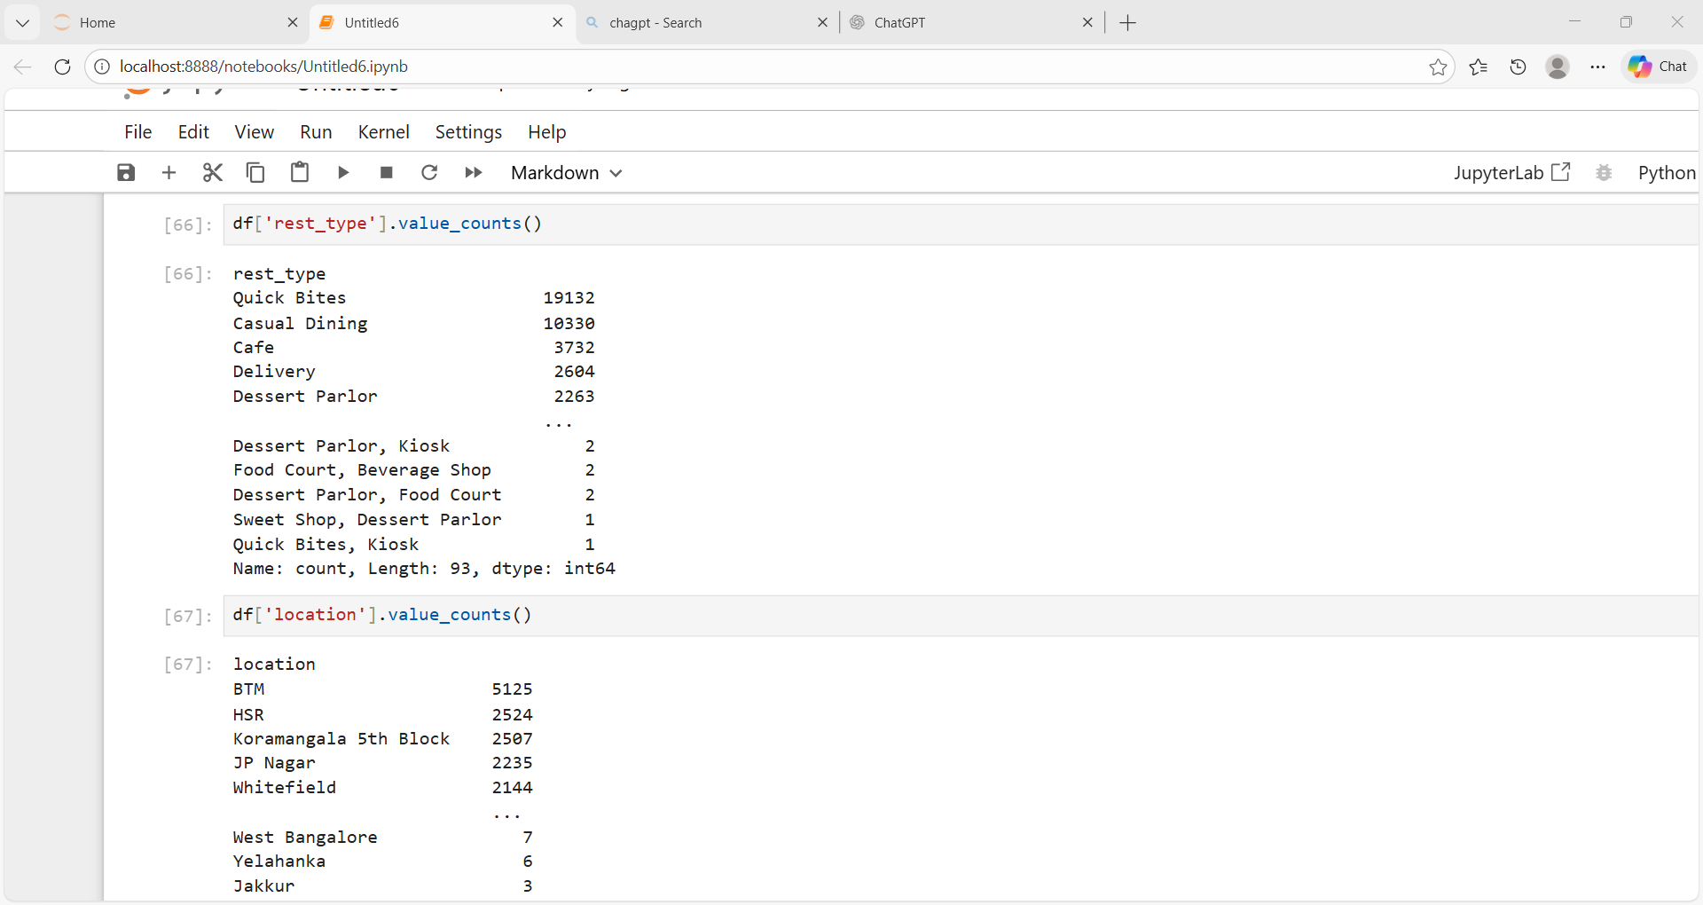
Locations:

Unique values:
Unique values are the distinct, non-repeated values present in a dataset or in a specific variable/column.
Cuisines:
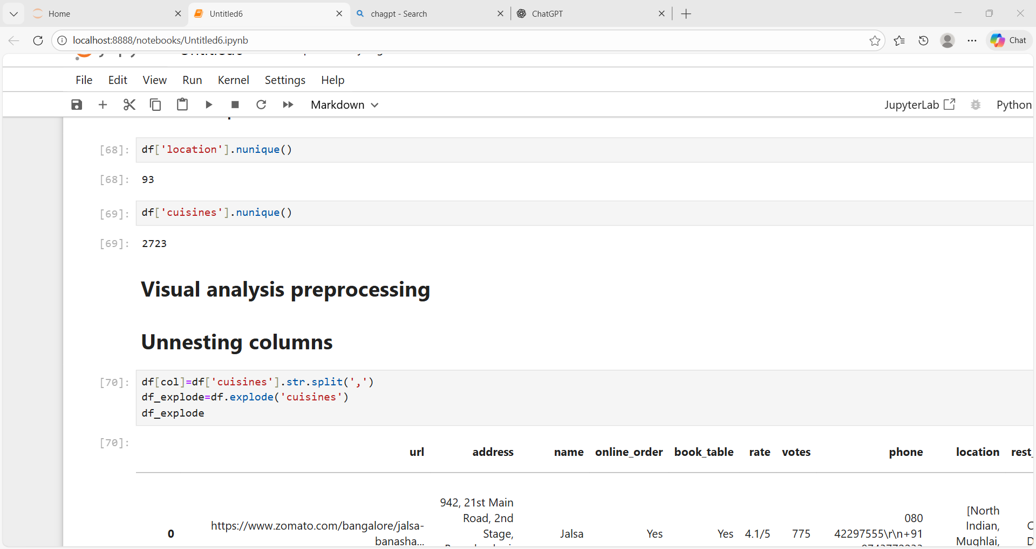
Locations:

Visual analysis:
Visual analysis is the process of examining data through visual representations (such as charts, graphs, or plots) to identify patterns, trends, relationships, and outliers.
Data cleaning:
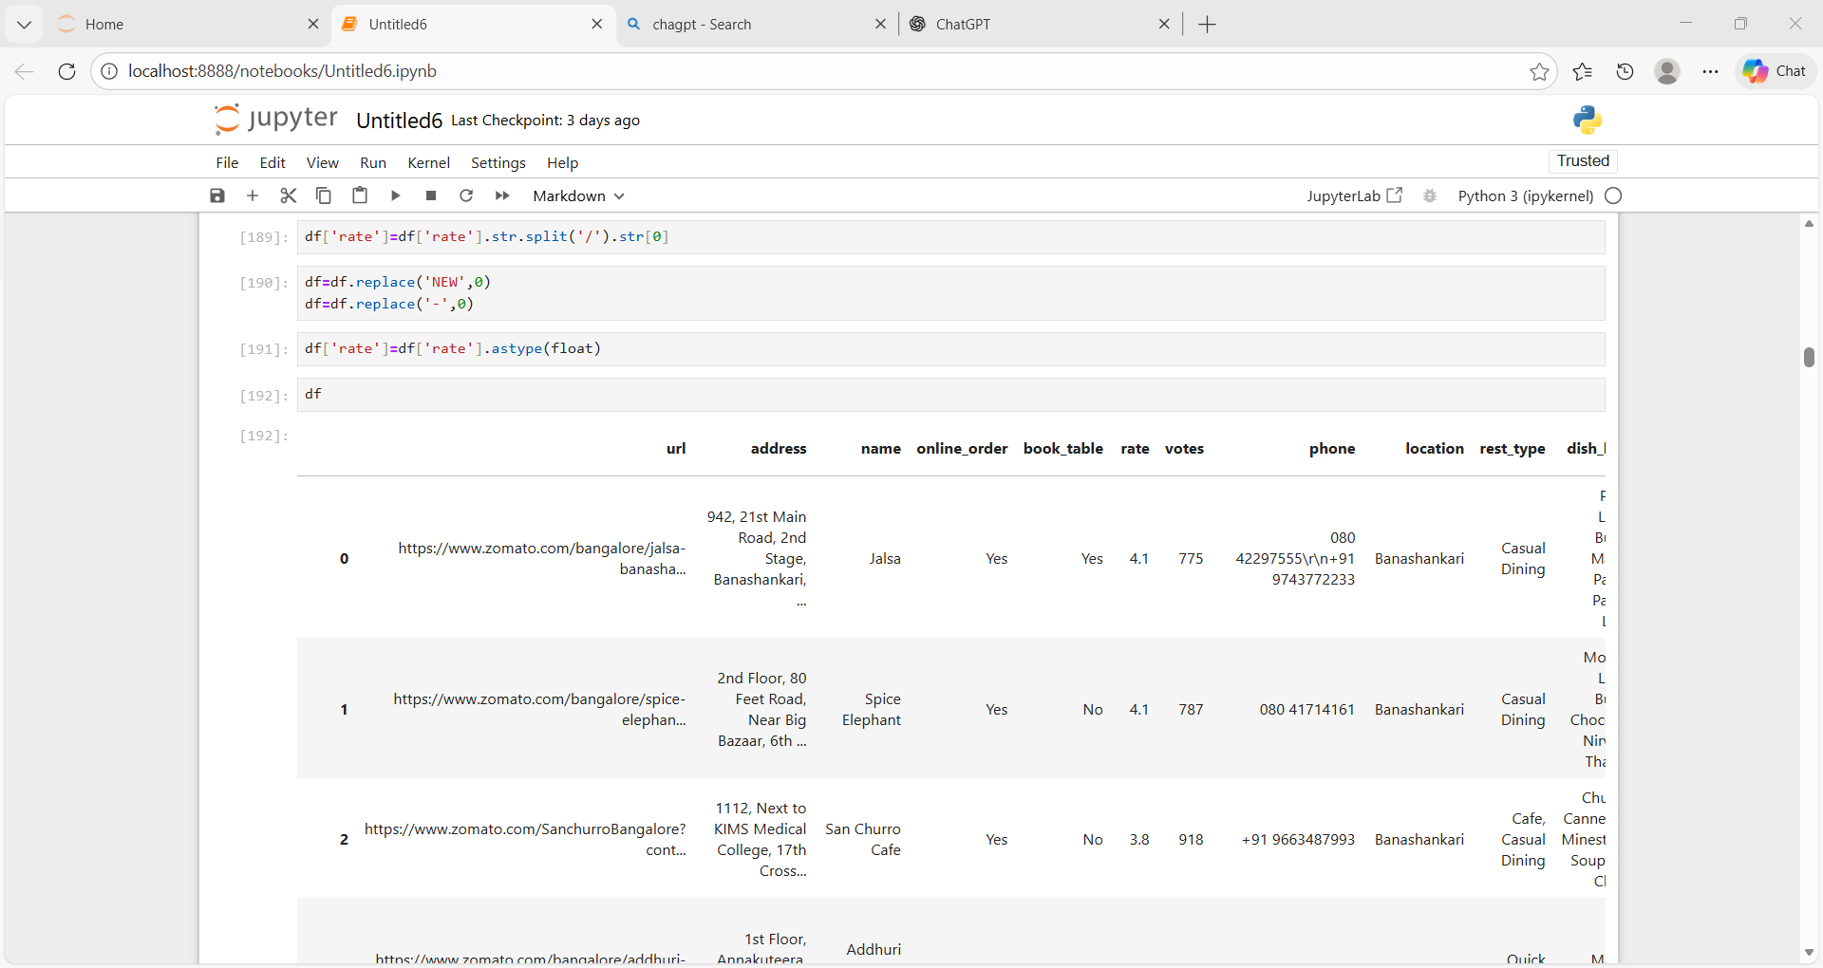
convert cost column to numeric:
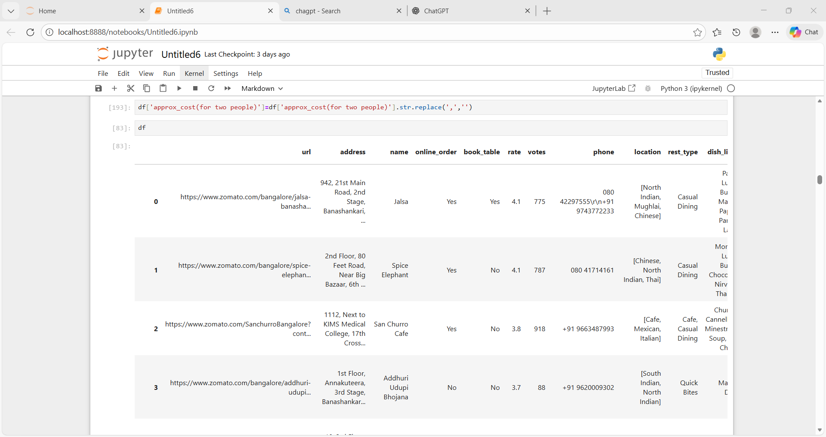
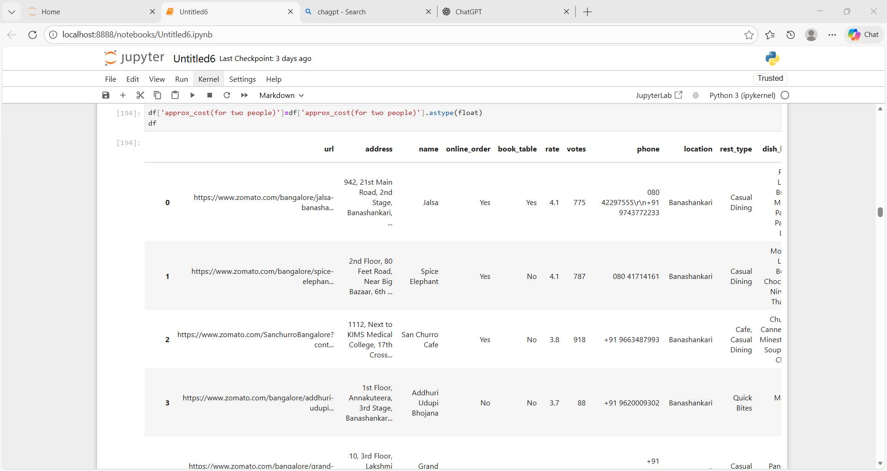
Removing duplicates:
To remove duplicates means to identify and eliminate repeated or identical items from a collection (such as data, a list, or records), keeping only one instance of each unique item.
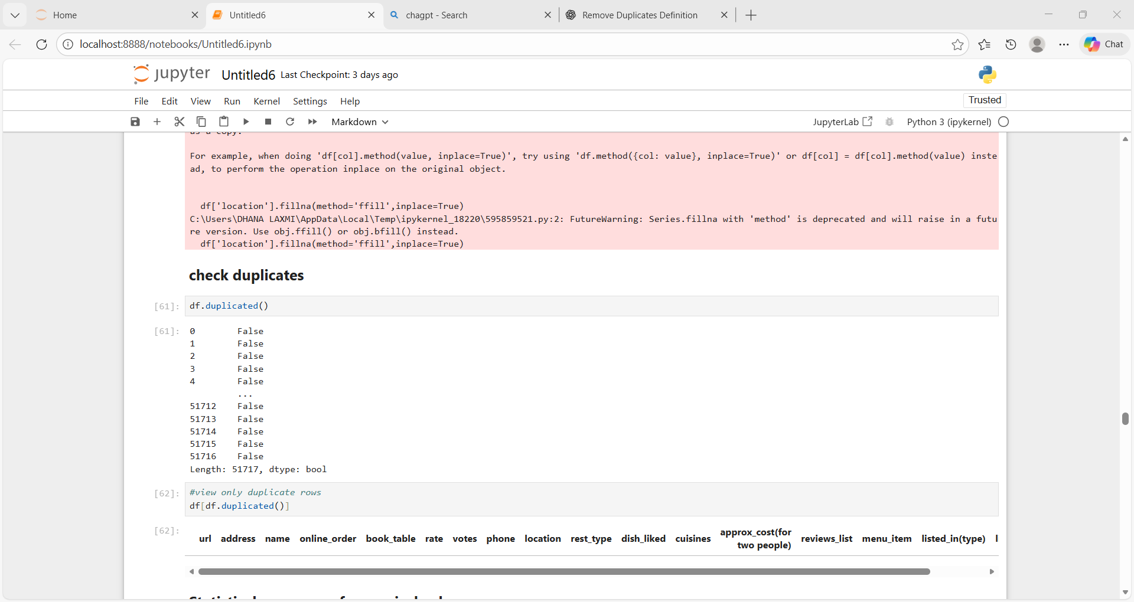
Univariate analysis:
Univariate analysis is a type of data analysis that focuses on examining a single variable at a time to understand its characteristics, distribution, and patterns.
Histogram/displots:
Ratings:
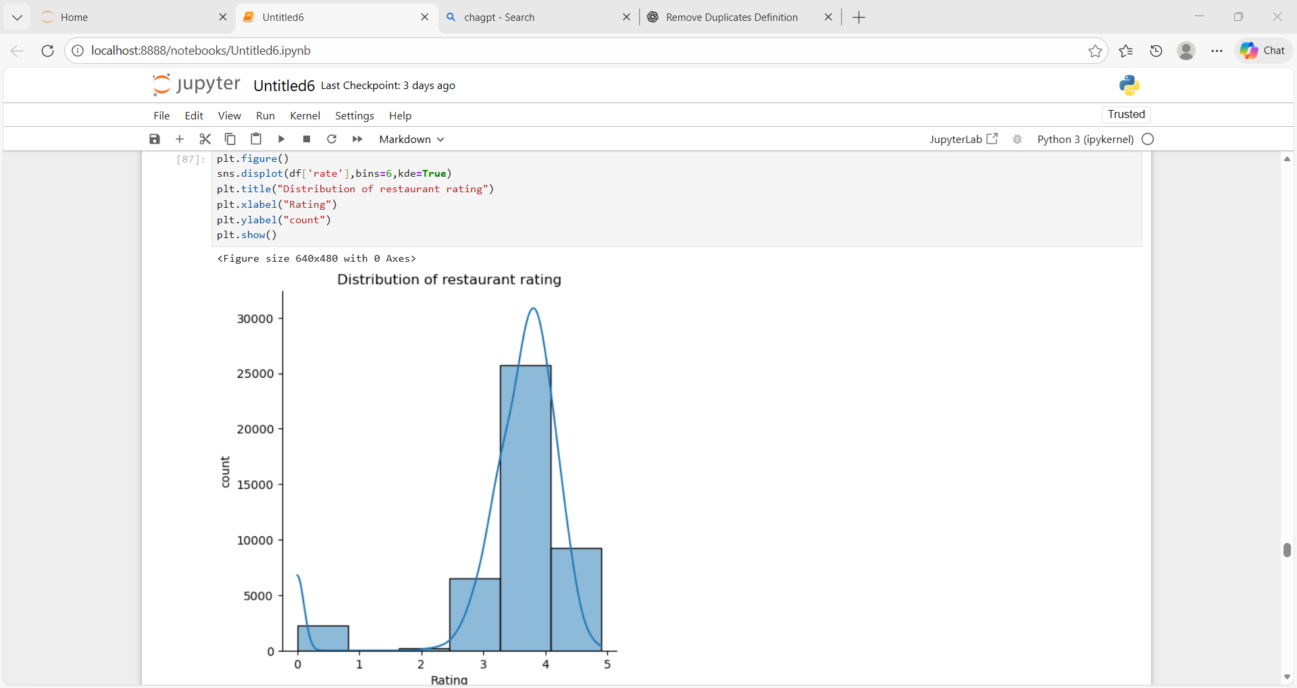
Cost for two:
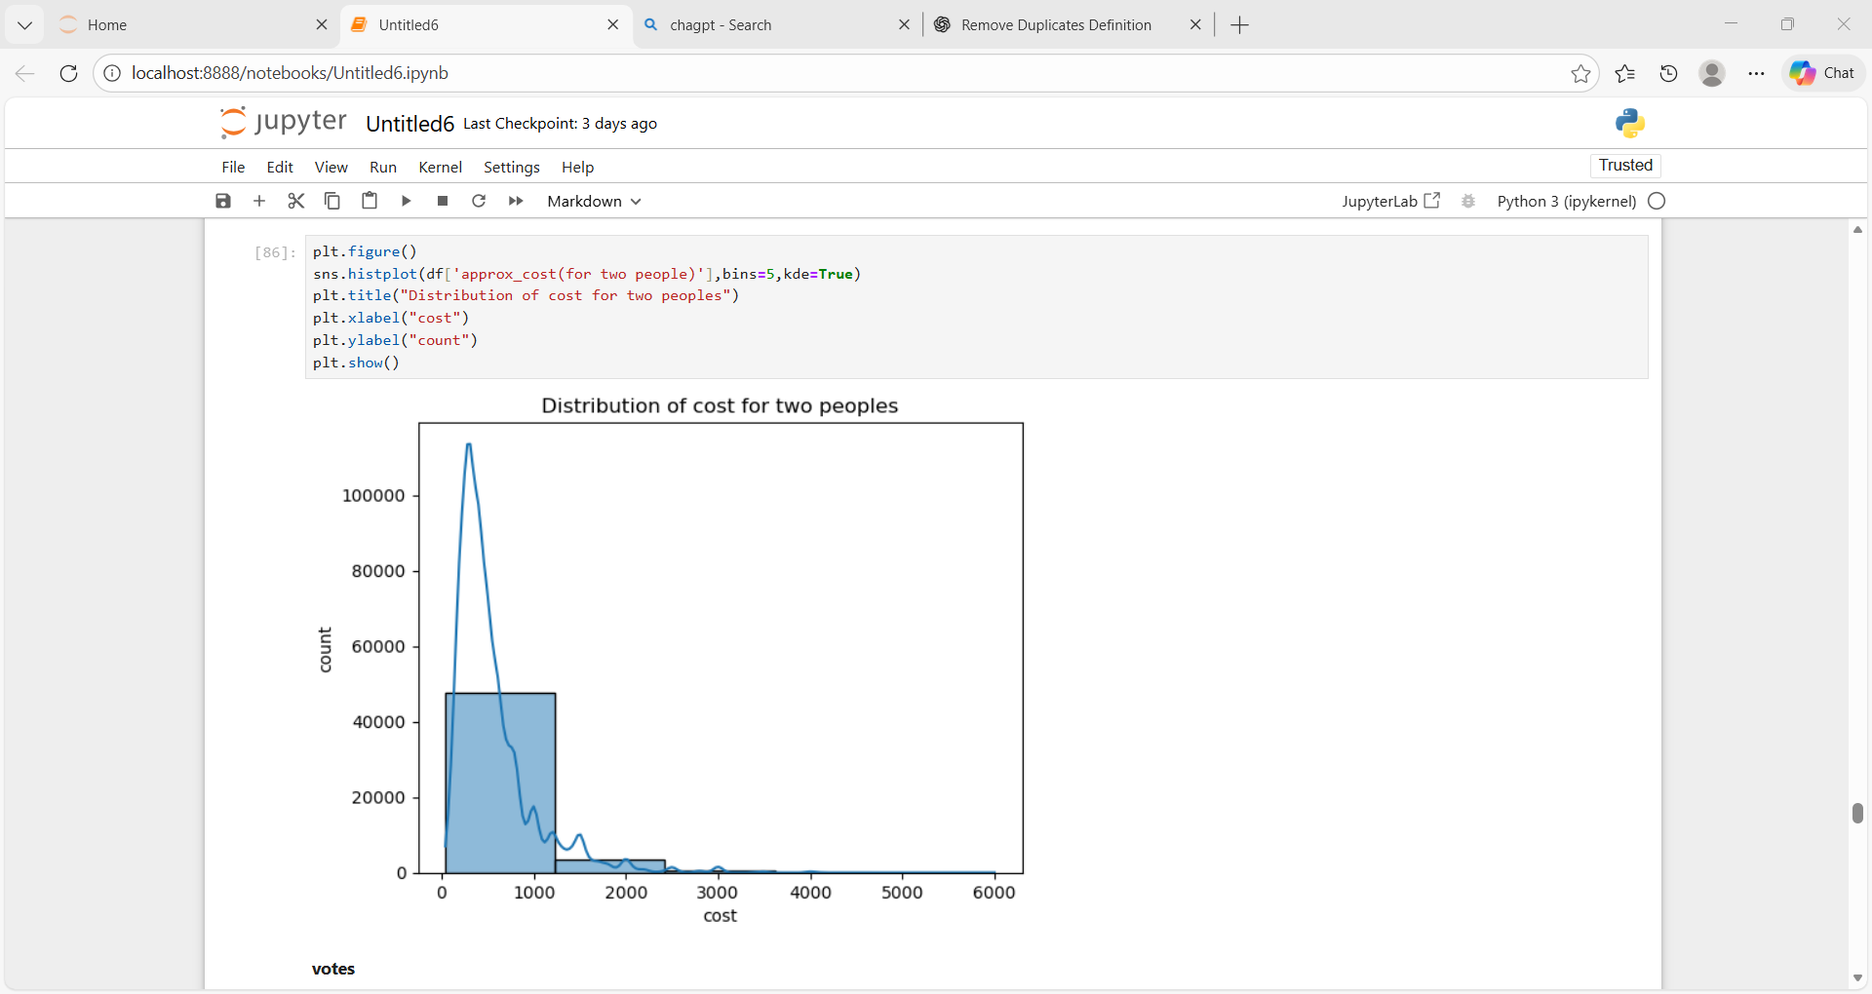
Votes:
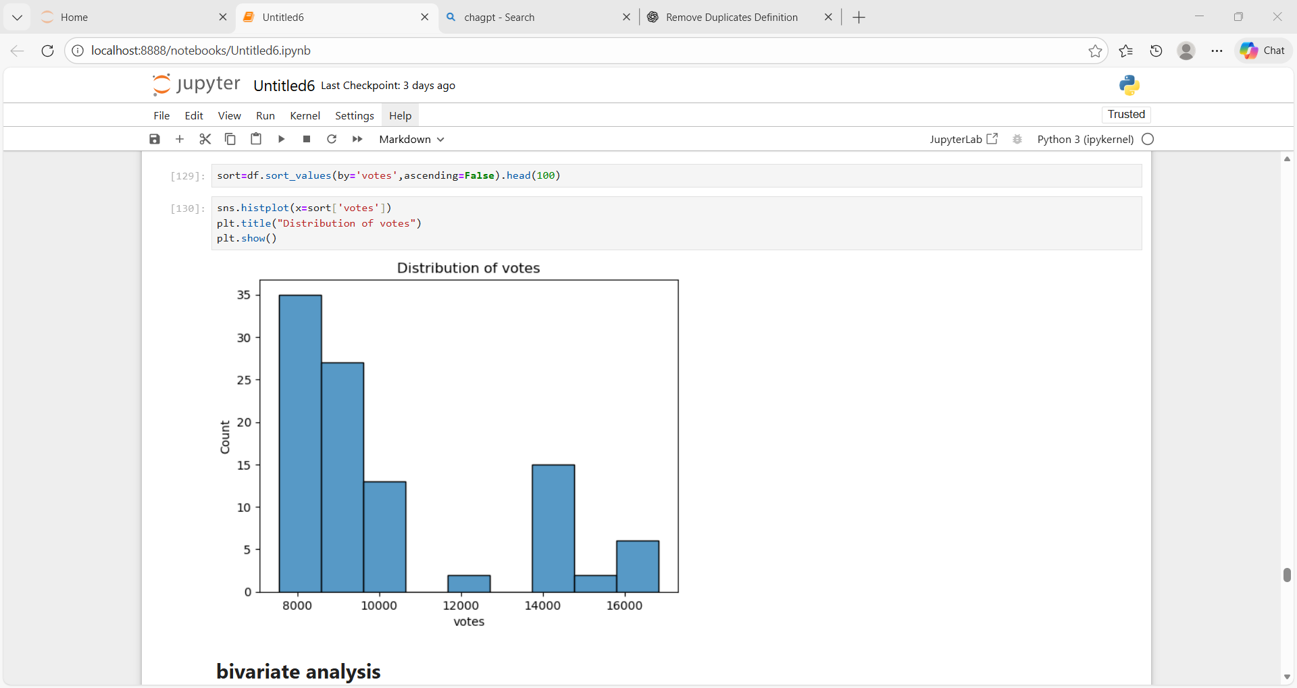
Bivariate analysis:
Bivariate analysis is a type of data analysis that examines two variables simultaneously to understand the relationship or association between them.
Boxplot
Rating vs online order:
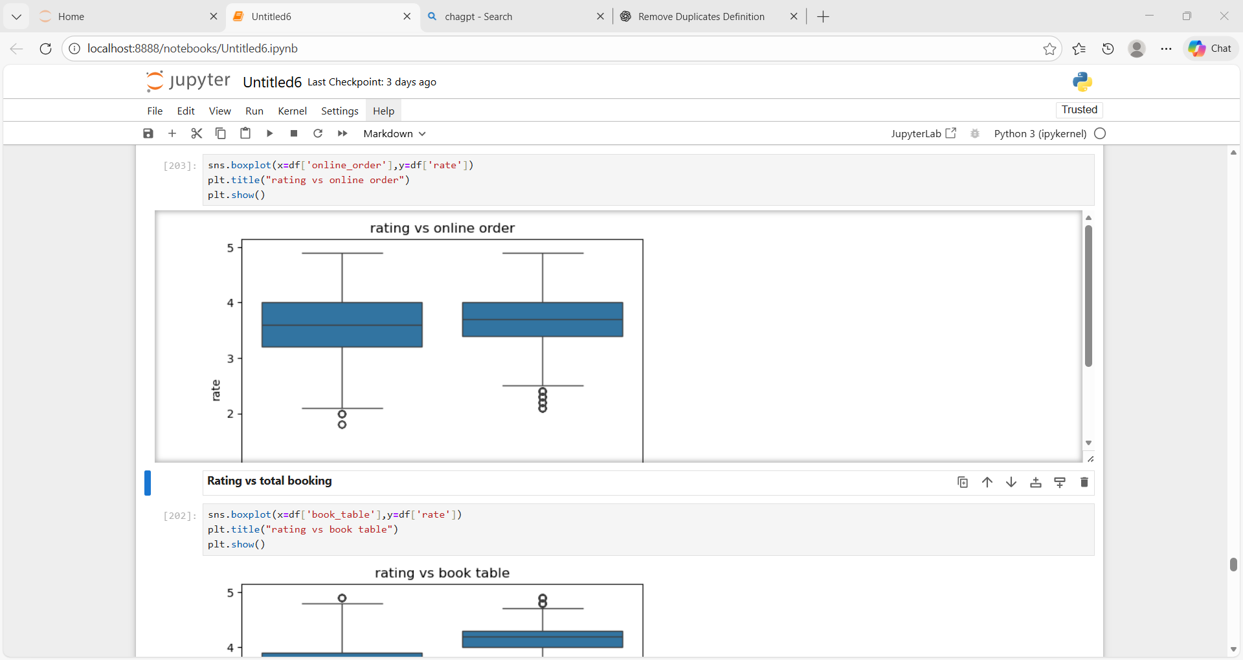
Rating vs table booking:
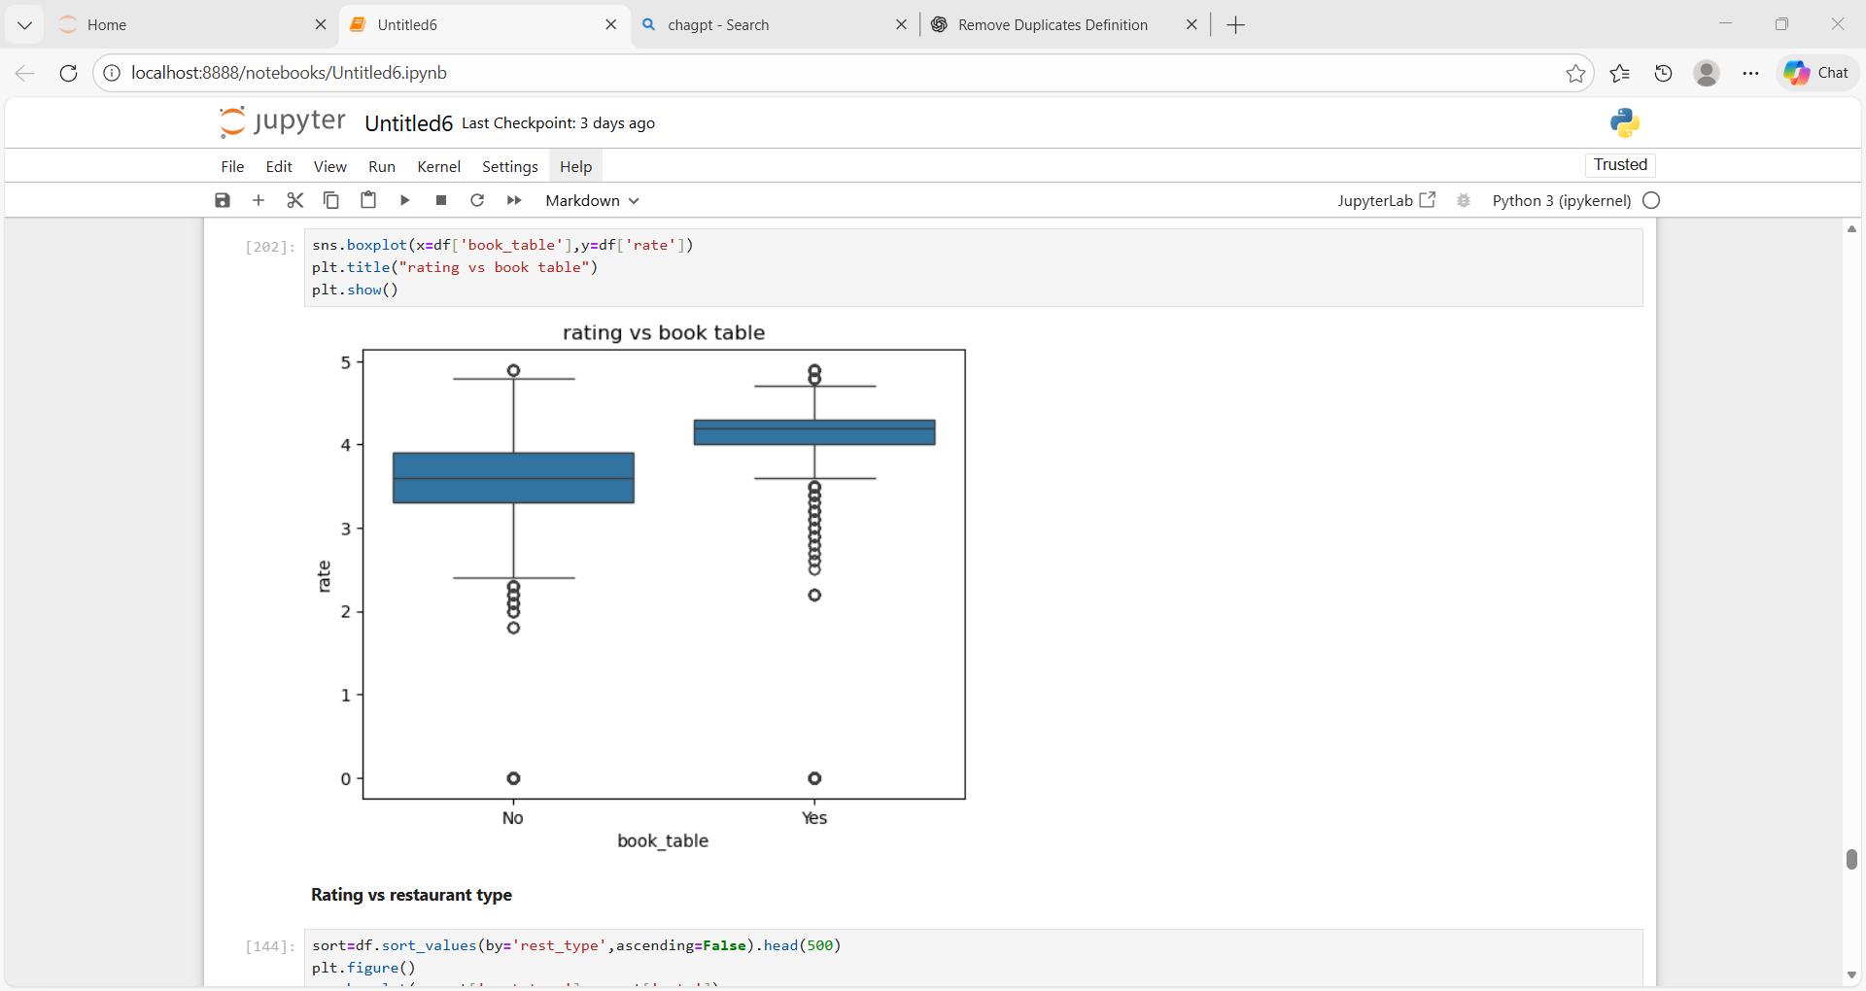

Rating vs restaurant type:
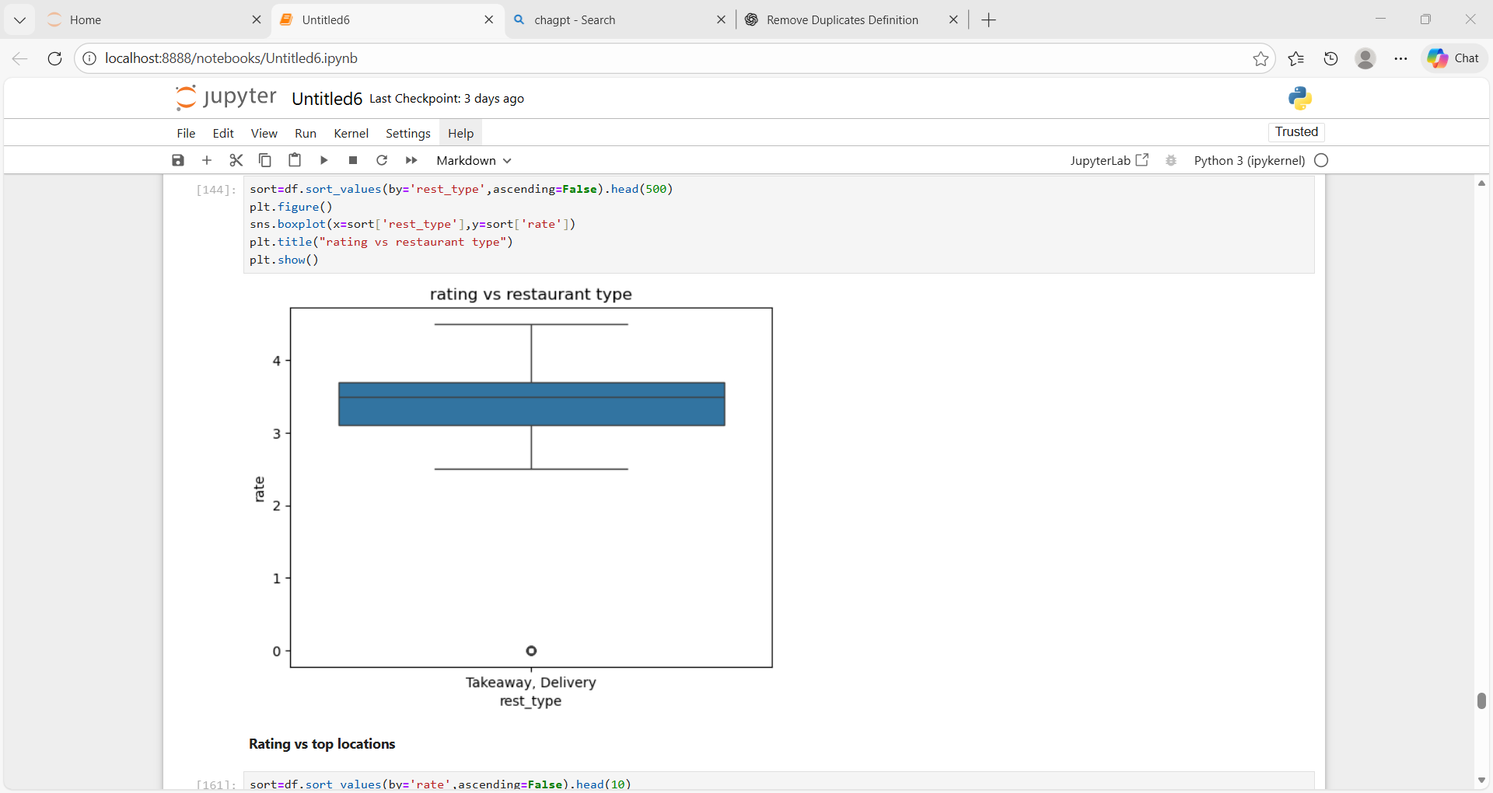
Rating vs top locations:
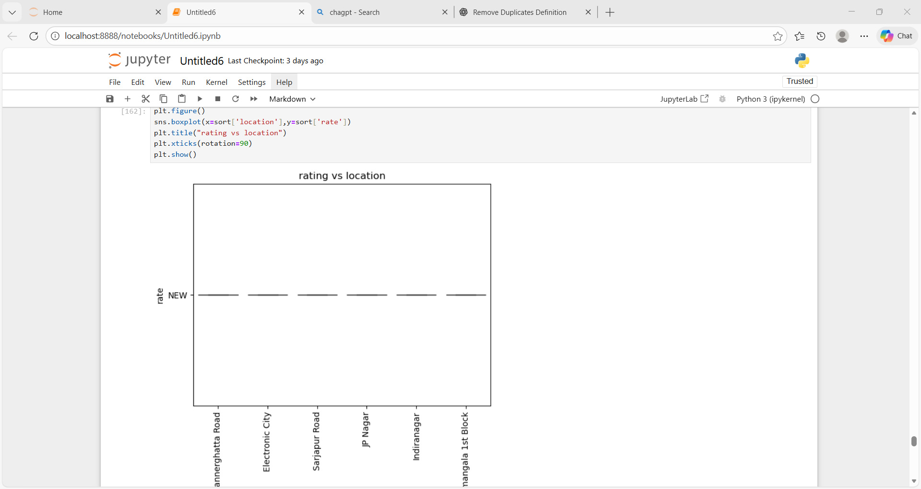
Missing value:
Missing values are data entries where no value is recorded for a particular variable or observation.
Rating, cuisines, Reastaurant type:
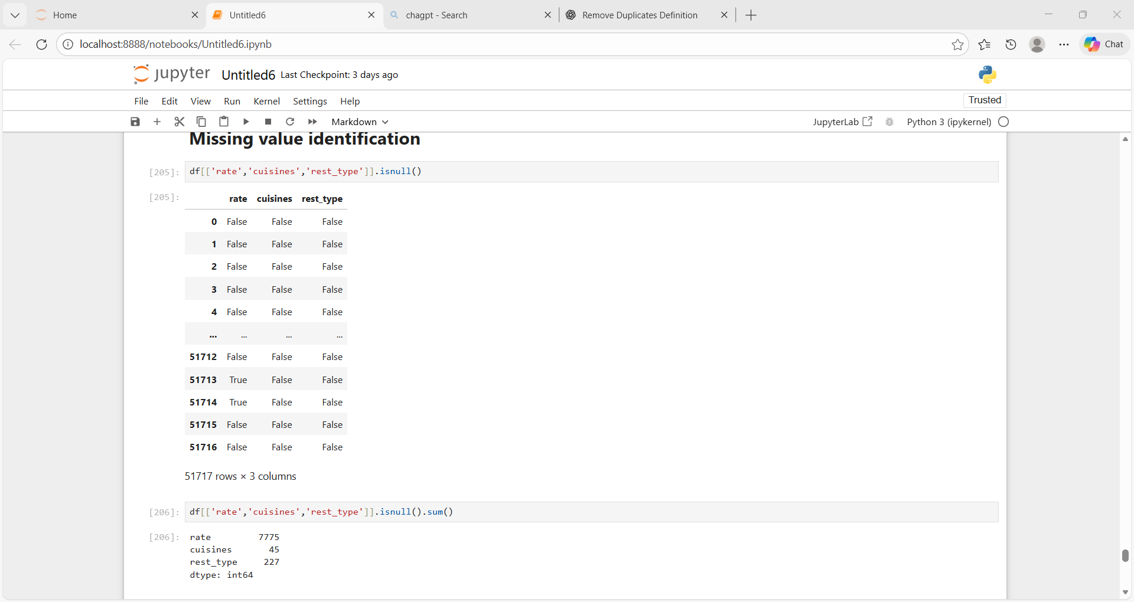
Outiler detection:
Outlier detection is the process of identifying data points that significantly differ from the rest of the data.
Cost:
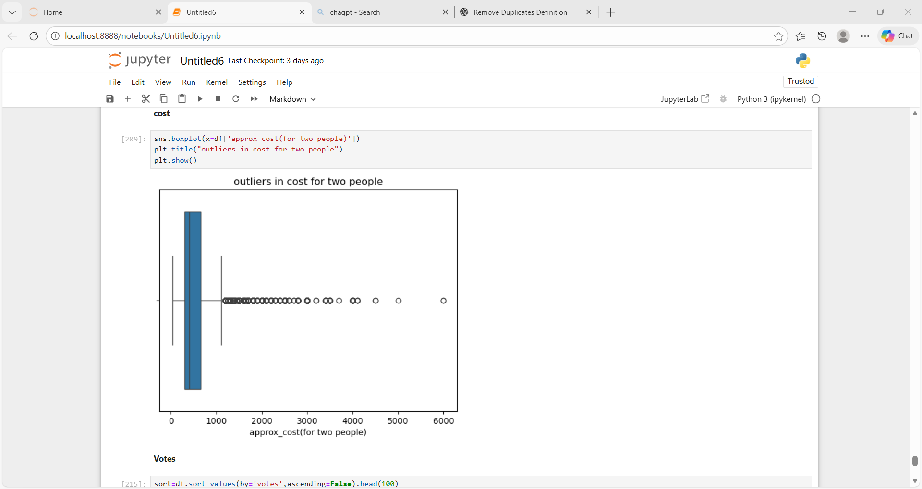
Votes:
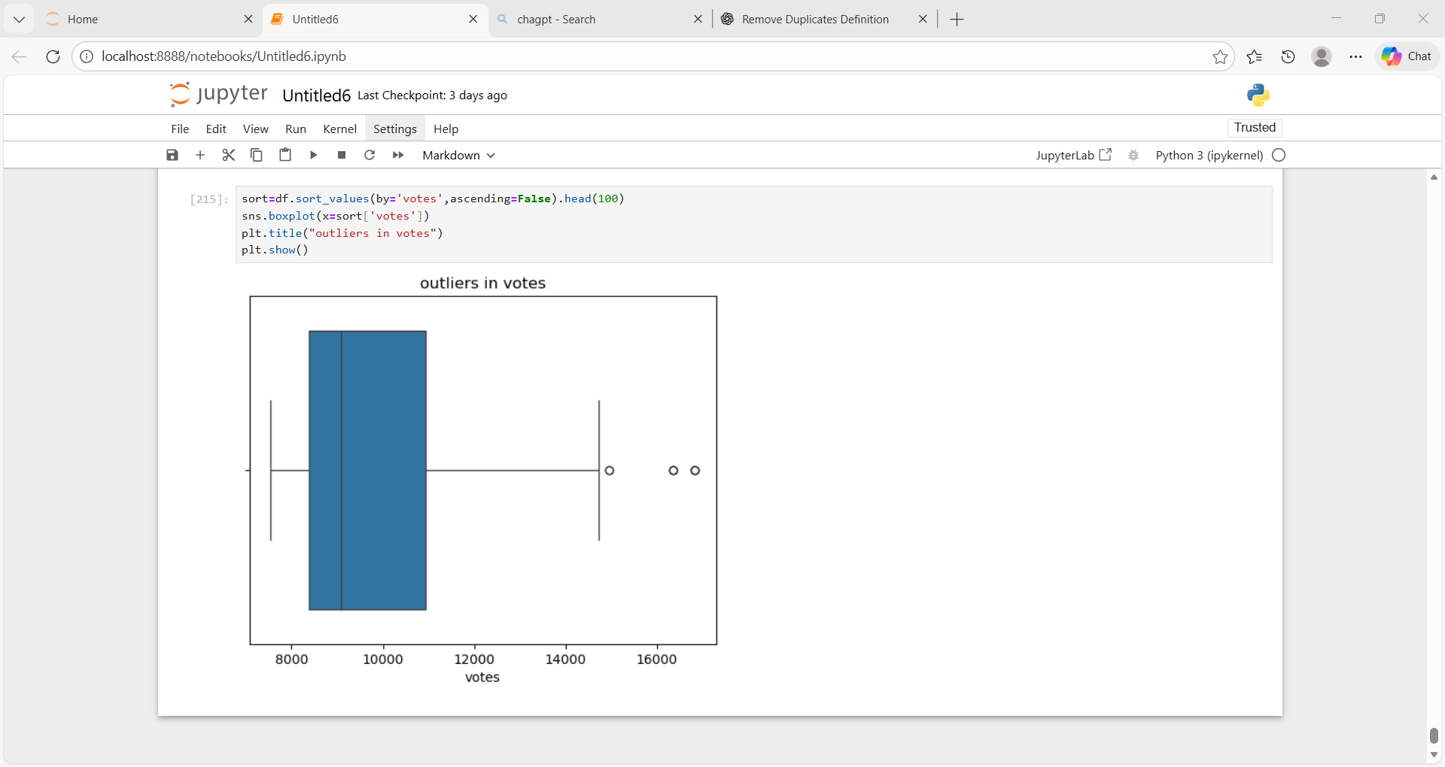
Insights for analysis:
Range of Attributes
Rating Range
- Ratings vary from very low to very high (approximately 1 to 5).
- Majority of restaurants fall between 3.5 and 4.5.
- Very few restaurants have extremely low or extremely high ratings.
- Indicates generally average to good quality restaurants on Zomato.
Cost Range:
- Cost for two ranges from low-budget to premium pricing.
- Most restaurants are priced between ₹300 and ₹700.
- Very few restaurants fall in the extremely high price range.
Votes Distribution
- Votes are highly skewed.
- Majority of restaurants receive low to moderate votes.
- Only a few restaurants have very high vote counts.
- Popularity is concentrated among limited restaurants.
Distribution & Relationships
Cost vs Rating Relationship
- Higher cost does not always result in higher ratings.
- Many mid-priced restaurants receive high ratings.
- Expensive restaurants do not guarantee better customer satisfaction.
- Customers value quality and service over price.
Service Availability vs Ratings
- Restaurants offering online ordering have higher average ratings.
- Restaurants with table booking show more consistent ratings.
- Convenience-based services improve customer experience.
- Digital service availability positively impacts ratings.
Plot-wise Observations
Rating Distribution Plot
- Ratings are concentrated around 3.5 to 4.0.
- Very few restaurants have extremely low ratings.
- Indicates a competitive restaurant market.
Cost Distribution Plot
- Majority of restaurants fall in the low to mid-cost range.
- High-cost restaurants represent a small segment.
- Market is dominated by affordable dining options.
Votes Distribution Plot
- A small number of restaurants dominate customer engagement.
- Most restaurants receive fewer votes.
- Brand recognition plays a major role in popularity.
Rating vs Online Order
- Restaurants with online ordering show higher median ratings.
- Online availability improves customer satisfaction.
Rating vs Table Booking
- Restaurants offering table booking show better rating consistency.
- Booking facilities enhance the dine-in experience.
Business Insights
- Restaurants offering online ordering consistently receive higher ratings and more customer votes.
- Mid-range priced restaurants perform better than very expensive restaurants in terms of ratings and popularity.
- Affordable pricing combined with good quality attracts more customers than premium pricing alone.
- Cuisines such as North Indian, Chinese, Fast Food, and South Indian dominate among top-rated restaurants.
- Restaurants with table booking facilities show better customer satisfaction and more stable ratings.
- Locations with high restaurant density experience greater competition and higher customer engagement.
- Restaurants in popular areas receive more visibility, reviews, and customer interactions.
- Customer engagement is concentrated among a limited number of well-known restaurants.
- Service convenience plays a major role in repeat customer behavior.
- Restaurants that adapt to digital services perform better on the Zomato platform.
Recommendations:
- Promote online ordering for all partner restaurants to improve ratings and customer reach.
- Encourage restaurants to adopt mid-range pricing strategies to attract a larger customer base.
- Focus onboarding efforts on high-demand cuisines to increase platform engagement.
- Expand restaurant partnerships in high-performing locations with strong customer traffic.
- Provide incentives to restaurants offering table booking services.
- Support new restaurants with promotional visibility to increase votes and reviews.
- Assist restaurants in improving service quality and delivery speed.
- Use customer reviews and ratings to identify and address improvement areas.
- Discourage overpricing without enhancing customer experience.
- Strengthen digital features to improve customer convenience and satisfaction.
Conclusion
- Most restaurants have average to good ratings.
- Mid-priced restaurants perform better than expensive ones.
- Online ordering and table booking improve customer ratings.
- Customer preference is based more on quality and convenience than price.
- Overall, digital services and good customer experience lead to better performance.

